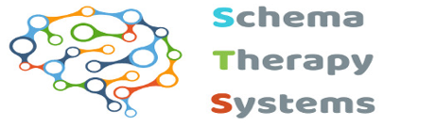

Registration form for workshops/modules 2024/25

This form should be completed by applicants not following the ISST Certification route

Name (including title for certificate):

Preferred name: Profession:

Address including post code:

Email:

Modules (Please indicate which module(s) you would like to attend by placing an ‘x’ next to ‘I wish to attend’

Module 1/Introduction to Schema Therapy. Dates: 9th, 10th & 11th December 2024. Cost: £390.00. I wish to attend this module:

Module 2. Dates: 20th & 21st January , 2025. Cost: £260.00. I wish to attend this module:

Module 3. 17th & 18th March, 2025. Cost: £260.00. I wish to attend this module:

Payment can be made by BACS.
Account number 12623524 IBAN: GB58SRLG60837112623524
Sort Code 608371 Swift/BIC: SRLGGB2L

Payments to be received 2 weeks prior to course commencement.

If paying by cheque, please make payable to ‘Schema Therapy Systems Ltd’
£
Please state the value of the payment you have made.

If your Trust/Health Board/employer is paying, please provide invoicing details below. Please note that places on the training are not guaranteed until payment has been received.

Name & address/department we should invoice (inc postcode):

Telephone number/email address:

Purchase order number:

Please return to Schema Therapy Systems by email to: schematherapysystems@outlook.com

Whilst we understand that unforeseen events occur, accepted candidates dropping out of the training programme, when we cannot easily fill that place, can result in a financial dilemma. As such, in order to run this intensive training for such a small number of trainees it is not possible to refund fees received after the two-week statutory cooling off period regardless of circumstances.

If you wish to undertake ISST Certification please complete the ‘Application for Standard or Advanced Certification’ form and return it to us

